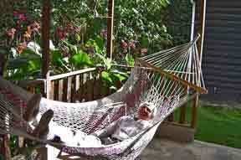
Costa Rica January :: Rest into Quest

Rest was on our minds after a busy fall. We had often thought of Costa Rica as a place to visit – its famous birds, its coffee, its example of the advantage of abolishing the army & investing the savings in schools.
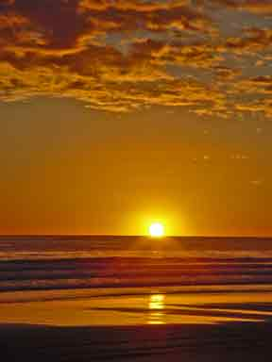
Certain perplexities that came up in planning should have warned us: too many places that seemed attractive with different sorts of sights, too far apart or hard to get to or get into, reports of crowding, quotas, over-development.
Gail pressed on. We agreed finally that what we needed most was not trekking in 4x vehicles from one crowded cloud canopy to another, certainly not relaxing on rope relays to see monkeys & get seen by them; no, rather, time down in some quiet place. So she settled on a fairly upscale lodging by the Pacific ocean in what proved to be a downscale sector of the coast: between the advertised beaches of Manuel Antonio National Park (Quepos) & those of Domenical, at Matapalo, reached only by a stretch of unpaved road (perennially “to be paved next year”) as we would learn from our pants’ seats.

To give us a sense of the urban chaos we were escaping, Gail’s cousin David drove us around San Jose in the afternoon rush hour. The tangle of little bars & restaurants around the university made us think of Tokyo’s Shinjuku at night. He warned against risking parts of downtown after dark.
Next morning David set us off in our rental car northwest along the Interamerican highway, with careful instructions how to get past the airport & find the turn towards Atenas & Grecia. That road was narrow, but reasonably paved & not too busy: I loved grinding through the hairpin switchbacks shifting gears up & down.
At one point, behind us was the central valley, but ahead down the valleys & ridges into the distance was a shimmering blue-green patch of water – suddenly the Pacific. Instinctively I wanted to stop for a picture, but kept going. Only later did I map the moment onto Keats
Or like stout Cortez when with eagle eyes
He star'd at the Pacific--and all his men
Look'd at each other with a wild surmise--
Silent, upon a peak in Darien.
We made the sharp turn at Orotina, rolled past the resorts of Jaco, crashed for lunch at a shaded restaurant by the Tarcoles River, but didn’t walk over to see the crocodiles on the silty banks.
At Quepos, we had at least to try the road for Manuel Antonio; but it was so over-built with tourist attractions that we turned back half-way up: made you think of places like the approaches to Sirmione or Kuta-Bali. We did stop, though, crashed for a grilled octopus & a fresh batido (frappe) of fruit (pineapple, mango, papaya. blackberry) at El Avion – a bar created from a U.S. military plane destined for the Contras in Nicaragua but sold off for scrap. Then we hit the hard road to our spot.
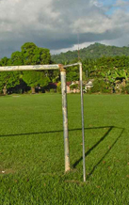
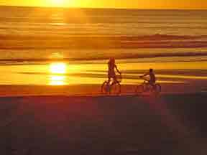
The road surface was big smooth pebbles more than gravel. The bridges were historic − one lane, rickety, built for a banana trade that long since left these parts, trembling under massive trucks. Every village had its soccer field & school where another country would put the Plaza de las Armas & the church.

Just before sunset we found Matapalo & our Behari Beach Bungalows. Our lodging was an orderly tent, its front flaps open towards the ocean, which we could see a few hundred yards away through the columns of coconut palm & the leafage of sea almonds. My first thought was to get pictures. The reception was Austro-Hungarian − cordial enough, but without local color; likewise the food & over-priced. The tents were elegant, but closely packed in around a tiny pool. The ocean was as loud as Second Avenue at home. We would have to look further.
The beach lured again at dawn:
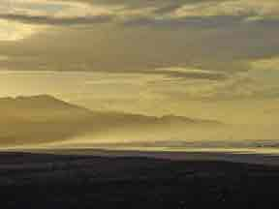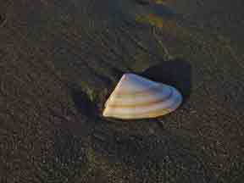

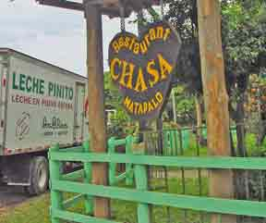
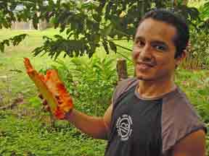
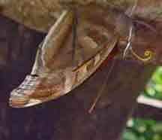
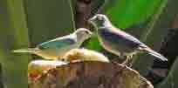
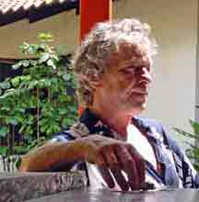
We never went back to the artificial rusticity of the Behari restaurant & its pricey continental or American breakfasts. Instead we found a local road house − Chasa − up on the highway by the bridge that rumbled like thunder every time a truck crossed, but where Michael, the manager, had studied ecology & biology at the university & likes to attract butterflies & birds.

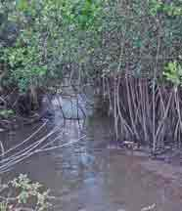
Breakfast of gallo pinto con patacones produced fried rice with beans & plantains breaded & deep-fried.
Still, we checked out the other locales, found one belonging to a French-Canadian expatriate, Michel, who told us of his retreat to the warm climate & lured us to try his fresh lobster dinner.

Following tips from him, we drove up along the local river until we came to a ford, which we didn’t want to risk without 4x, so we never got to the waterfall. Then we drove out into the nature reservation along the shore preserve to see the mangroves he described, wondering what the tall grass in the center of the road might do to our car. We glimpsed mangrove, but by then it was nearly dark, so we rushed back to get our lobster at 6:30. In all we were eleven hungry people, including two German chemists who had been surfing without much to eat.
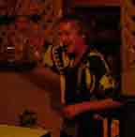
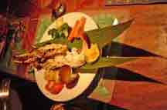
Michel was tipsy from the start. It was nearly 8 o’clock before he managed to produce guacamole on palm leaves, maybe 10:30 before we saw the lobsters. The Germans were numb. The elegant sculpted fruit dessert took till midnight. We felt hardly able to believe, let alone react, defend, as we waited for the next spectacular presentation (they were delicious & well designed). He had us enthralled, trapped: the way guests at the banquet of Trimalchio must have felt. Needless to say we didn’t go back next day to have him lead us further into the mangrove swamp.
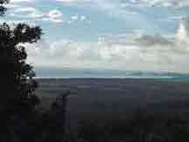
At our favorite Chasa out on the main road, Gail did some sketching, which attracted Ron Brutsche, an American developer with the vision & energy of an old-time pioneer, who then drove us to the next town & up the mountain to see ocean view lots he has bulldozed out of the red earth − view all the way to Manuel Antonio on the far right − too rough for us, isolated, but he did show us a great bird, the chestnut mandibled toucan that was there on a branch just waiting when the pickup truck arrived, I was too far & too slow to get out my camera before it flew.

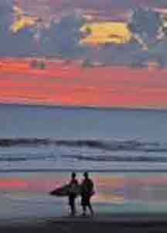
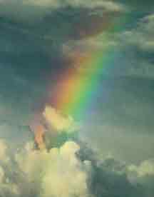
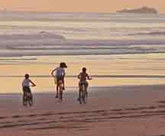
The surf that looked fabulous in every different light, above all with a rainbow, seemed to get louder & closer each night, as the moon waxed. How not to remember the tsunami? We found charming Ron’s grand children silhouetted on the beach at sunset, but restlessness had set in. We had pretty much explored what there was to eat & see, with whom to talk. It was time to look for a different spot. It seemed clear, too, that the guidebooks were too cautious about the need to book lodgings in advance. We would take our chances but via the southern route, down to Domincal on the coast then up through San Isidro El General. From there the Interamerican goes back to San Jose via some of the highest roads but we could do it in stages. The trip down had been too much mountain driving for one day.
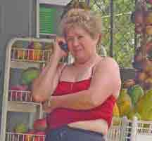
Meanwhile, my arms & legs were covered with red spots that itched viciously, like chiggers at home. Gail followed suit with an even worse attack. Sand fleas, I thought, but it turned out to another example of Costa Rica playing host to more varieties of creature than anyplace else on earth: purrujas (Ceratopogonidae − the family name, ‘horn beard’ or ‘horn tail’, which seems to fit the sting: the entomologist must have grinned as he scratched), also known as no-see-ums, biting midges, sand flies, punkies), very well documented on Google, but certainly not advertised to innocent guests at tent city Bahari Beach. Only plus from this part: once we got back to San Jose, Gail’s cousin Tobel took us to a physician of her acquaintance on the staff of CIMA − the finest medical facility in Central America.
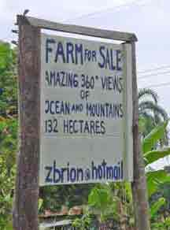
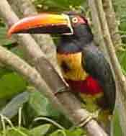
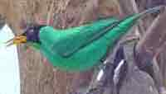
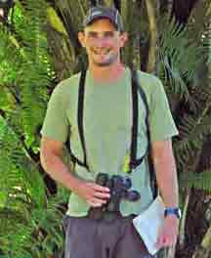
Along the way, more evidence of the real estate boom. Also, Michael, our host for local cuisine, had told us to look for a fruit stand near San Isidro where the owner puts out fruit to get birds. For the next night we had chosen Talari Mountain Lodge on the road up to San Gerardo Rivas, so we stopped for lunch at its neighbor, Rancho La Botija, which turned out to be a hillside botanical garden that also cultivates coffee & sugar cane in a small patch − owned by a surgeon & managed, it seems, by his Mexican wife, who advised us that her home grown tilapia was the best thing on the menu (it was tasty) & led us on a tour of the grounds.
Just down the hill, then, we found Talari & our cabin. Grounds on alluvial plain of the San Isidro river, which roars in the background − formerly all cleared for pasture, but now being reforested in part. Paths laid out & trees labeled so possible to study plants as well as birds. Detour to town to get antipruritic gel against the bites of purrujas. Highest density of shoe stores ever seen. Supper in lodge very simple to say no more − frozen shark & potatoes − but owner − émigré from Belgium − did play part of a Beethoven sonata afterwards.
Next morning at six we went on a bird walk with his son, which stretched to nearly three hours − first around the cabins, then down along the pasture to the river bank & back for breakfast outside near the lodge. Our guide, Pieter Westra, has printed a list of 212 species recorded from the place (complete with scientific names & page references to Styles & Skutch, Birds of Costa Rica). He helped us to find about 40 species in that short time, knows everything very well, by (even fleeting) sight & by sound, also our ‘North American’ warblers (chestnut sided, Tennessee, mourning, yellow) & a yellow-throated vireo. Very patient with awkward amateurs. He gives tours in English, Spanish, & Dutch.
Sightings at which he exclaimed most were pearl kite (two tiny puff balls perched on a tree out in the middle of a pasture), which is gradually extending its range northwards; black-shouldered kite (hovering dramatically while we ate breakfast); turquoise cotinga (very bright perched on very tip top of tall tree). Several times we saw the yellow crowned euphonia where the binomial has supplied the common name (Euphonia luteicapilla ‘well voiced with yellow plumage on head’).
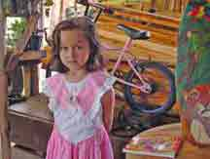
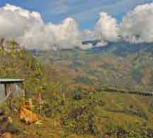
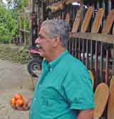
Restless again we studied the guidebook & decided that the valley of the Savegre river looked promising: down to the west from the Interamerican (km 80) on the road for a different San Gerardo (not ‘Rivas’ but ‘de Dota’).
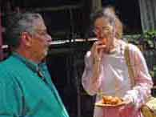
At last we were finding crafts along the road as well as a classic pastoral scene.

When we got to road at km 80, we could hardly believe how steep & narrow it was & seemed to go on for a very long time. Finally we got to a hotel well advertised in the guidebook: Trogon Lodge, also surrounded by rushing water, but furnished with a first class dining room overlooking ponds & the green valley. It was already 2 p.m., so we ate lunch: at $24 per person, among the most costly we’d met, but needed at the moment. A room was available & horseback riding & a nature tour to see the quetzal in the morning. That was something we hadn’t planned or hoped. Would it pan out? Still, we decided to check the other lodges advertised.
Driving by Cabinas Quetzal, we checked the working farm, Cabinas Chacon − sprawling up the hill, great hummingbird feeders by the office, bright flowers, even a pleasant cottage, but no guide available for the next day except in groups of 15. When we balked, the girl at the desk hinted that we go back to Cabinas Quetzal: “that’s where the birds come in the morning.”
There we found Orianna, who had lived in New Jersey, but prefers life here. She explained that all we had to do was cross the shaky foot bridge over the Savegre & walk halfway up the hill to the apple orchard. Quetzals come at 6:30 in the morning or 4 in the afternoon. Dinner at six.
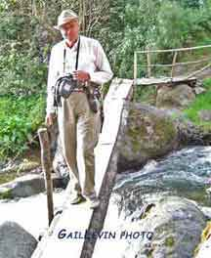
Too late we arrived to hear that a female quetzal had been & gone. Our informant was Italian from Brescia who packed a huge telephoto lens. He travels all over the world taking pictures of rare wildlife. He insisted that 6:15 the next day would be plenty of time.
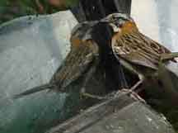
All afternoon along the way we’d been admiring an evident cousin of our white-throated sparrow − the rufous collared sparrow (Zonotrichia capensis on Pieter Westra’s list). We got back to find one attacking his alter ego in our car, first in the mirror, but when we covered that with plastic bags, then in the side window glass. Emphatic guano dripped down the side.
With all the excitement, I’d scarcely noticed how much trouble I was having to breathe: altitude 2,500 meters our friend from Brescia explained. I began to feel, too, that my throat was sore. That became even more apparent when we realized that our cabin had no heat. There was a heap of blankets. We spread them all but I felt an attack of chills & trembling, found I was running two degrees of fever. It was a rough night. We were awake before the alarm clock could go off.
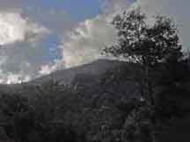
Had to be up there by 6:15 I kept telling myself. But every step hurt, like at Macchu Picchu even if nowhere near so high. I struggled up to the little plateau below the orchard & we found a rusty bench to sit on. It was only six. Still murky. No birds, not even songbirds. A cold wind. Our Italian arrived lugging his scope & disappeared up the hill behind a tall tree where the quetzals had been seen to set up his tripod behind the apple trees.
Half an hour passed. A group arrived from Trogon, where we had not stayed. I wondered now if those rooms were heated. Must be. If only…! Their guide pointed out a big floppy black bird, black guan: it keeps the quetzals away, he said. The quetzals will come, he added. The refrain went back & forth.
The wind seemed colder. But sunlight now began to turn the opposite slope behind us golden, gradually creeping down. Still no morning chorus of voices − so different from the morning before. The group from Trogon left in defeat. If we had stayed there, we would have been retreating too. It was past seven. The Italian came down to reconnoiter. We all looked at each other & shrugged. It made me think of how three of us boys looked one winter day when we trudged from town to the top of the hill to ask Roger Patterson for permission to trap muskrats in his crick & he said no. We were crushed.
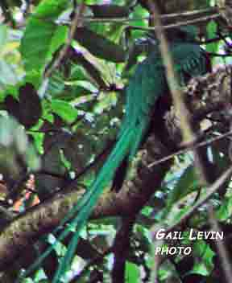
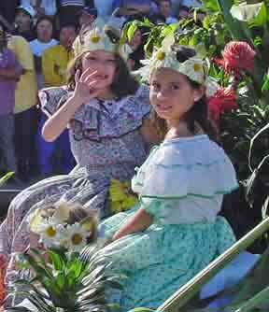
I spotted a group of four or five coming down from the road & across the bridge. Their scopes seemed huge even from so far & they walked with such determination. It seemed superhuman since I could scarcely breathe or move. They went first to the left, to a tall, fruited tree above a giant, mossy boulder, but then came over to us on the plateau. They set up their scopes & almost immediately their leader declared that he had two quetzals − a male & a female: come look. He also let Gail place her camera to the lens of his fat scope, with good results. Kevin, the guide for that group, then led them on to yet another spot in the same valley. We were elated. The pain had paid off. But now we had to get back to San Jose & start to put ourselves back together.

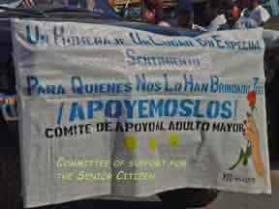
It was Sunday afternoon, though, & thinking of traffic coming back from the country in Rome or New York, I insisted we try an alternative to the Interamerican route. We turned off to what the guidebook describes as a string of pleasant towns named for saints, where the road winds through hills thick with coffee plants grown in full sun, the beans bright orange. Nowhere, though, could we find a restaurant open or what we would want − certainly not the Castelli Romani. At one place, besides, a parade blocked the only way through town: we took pictures, & pictures, even a movie: In the end, we had to wind back to the main drag.
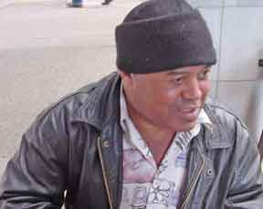
With warm hugs, hot soup made of yellow squash, & a trip to the friendly physician Gail’s cousins helped to pull us together again. Monday, David took us to see the Museum of Pre-Columbian Gold − underground in the city center: elegant amulets, collars, pendants in beaten & cast gold (shades of Mycenae 3000 years later), also dioramas & clear charts in Spanish & English, showing the rise from hunting & gathering through agriculture & the development of socio-political hierarchy, incipient empires, powers of warriors & shamans.
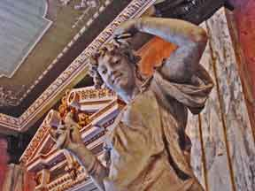
Afterwards, David arranged first-aid for my scuffed & dusty shoes, then he offered us an excellent coffee at the Opera House, which was built in an opulent baroque style by coffee barons who contributed a dollar per exported bag. Then he guided us to a source for reproductions of the lost-wax gold images less exorbitantly priced than the museum.
Monday morning I was sitting at the kitchen table editing pictures when I felt everything shake & tremble a little. Gently. Gently. “Do you feel that?” Gail called from upstairs. “The pictures are moving on the walls.“ Our first earthquake, 4.9 on the Richter scale as it turned out. “Un seismo quasi turistico” − perfect climax for an unintended quest.

John B. Van Sickle
© 2005

